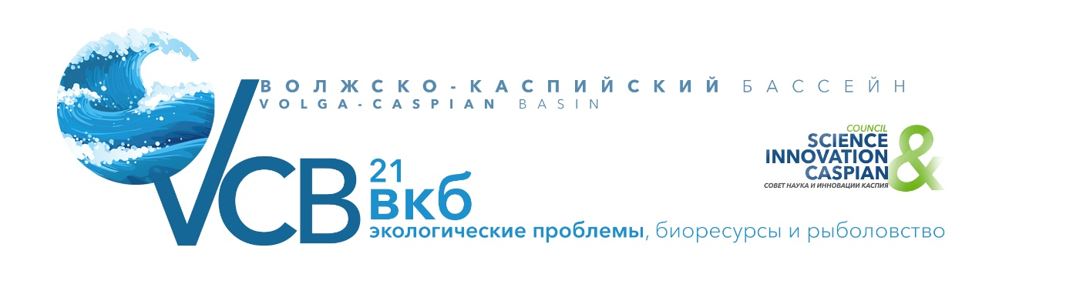

INFORMATION ABOUT THE FORMS AND CONDITIONS OF PARTICIPATION
IN THE CONFERENCE.

Working languages of the Conference: Russian and English
Forms of participation in the Conference: full-time and remote.
Location face to face meetings and online broadcast of the Conference: Moscow, Institute of ecology and evolution Russian Academy of Sciences.
Conditions of participation in the Conference for various categories of organizations:
- All non-profit organizations, scientific institutions, mass media and government representatives take part in the Conference without paying the registration fee (with the exception of placing an advertising module in the Conference Bulletin).
• all commercial companies, regardless of their form of ownership, have the right to participate in the Conference, provided that the registration or sponsorship fee is paid in advance (before the start of the Conference).
- enterprises that are under the simplified taxation system are provided with significant discounts on participation.
TYPES OF REGISTRATION FEES:
VIP PACKAGE «FULL-TIME PARTICIPATION WITH A SPEECH» €560
(non-refundable)
"BUSINESS PACKAGE FULL-TIME PARTICIPATION WITH A SPEECH €390
(non-refundable)
"BUSINESS PACKAGE FULL-TIME PARTICIPATION WITHOUT SPEECH €280
(non-refundable)
Package "Accompanying person" (non-refundable) €95
BUSINESS PACKAGE «REMOTE PARTICIPATION WITH A SPEECH» €280
(non-refundable)
BUSINESS PACKAGE "REMOTE PARTICIPATION WITHOUT SPEAKING" €170
(non-refundable)
INFORMATION in the Bulletin (1 page-A4) about the participating company 10,000 rubles
The PARTICIPANT pays for the ordered services on the basis of the invoice issued by the ORGANIZER. The application is considered accepted for execution when the PARTICIPANT pays the registration fee. At the same time, the ORGANIZER, after receiving the Application, can provide services to the PARTICIPANT and insist on their payment in the subsequent period.
If the PARTICIPANT refuses to participate less than 20 days in advance, the ORGANIZER guarantees payment of a penalty of 100% of the size of the declared participation package.
Requirements for the report/presentation:
* The duration of the report is not more than 15 minutes
* The duration of the speech is not more than 7 minutes
• The language in which the presentation can be made: Russian or English
• The topic of the presentation should coincide with the topic of the session
* The presentation may be accompanied by a slide show
Those who wish to speak at the Forum should:
* Send an application to the Organizing Committee, indicating the session at which you plan to speak - by March 15, 2021
* Send the topic of the speech (title of the report) to the Organizing Committee - by March 15, 2021
* a color photo of the speaker in the format of at least 3 x 4 centimeters in electronic form (bmp, jpg or tiff file format)
• information about the speaker (short summary) to be presented by the Moderator of the speaker's session to other Forum guests
* abstracts of the speech (until March 20)
• Send the presentation (slides) to the Organizing Committee in electronic form in ppt or pptx file format - by April 10, 2021
Requirements for submitting abstracts:
* Abstracts (provided only in electronic form (doc file format), in the name of the files indicate the full name of the speaker of the section. (For example: Sergey Ivanov Петрович.doc)
* Abstract text without hyphenation and extra spaces in the format: single spacing, Times New Roman 10pt font, width alignment
* Margins: left, right, top and bottom – 15 mm.
* Article title-TIMES NEW ROMAN FONT, 10 PT, UPPERCASE, BOLD, CENTERED
• On the next line after the title – the full name of the authors separated by commas, starting with the underlined full name of the speaker. First the initials, then the last name of the authors
• Each report in Russian must be accompanied by an abstract in English (Times New Roman, 10 Pt), up to 500 words in length, including the title of the report, the full name of the authors, the organization, and e-mail.
• Each report in English must be accompanied by an abstract in Russian (Times New Roman, 10 Pt) of up to 500 words, including the title of the report, the full name of the authors, the organization, and e-mail.
• In the text of the report, use quotation marks like "...»

